Sara Alawieh
201601126 | sma107@mail.aub.edu | section 3
CIRCUITS AND ELECTRONICS LAB - ECE 312L
MyDAQ assignment 1

Table of Contents
I. DESCRIPTION OF THE HARDWARE SETUP 3
a. Circuit connections: 3
b. Connections between MyDAQ acquisition board and the circuit: 6
c. Input and output lines: 7
d. Photo depicting hardware setup and connections: 7
II. DESCRIPTION OF THE SOFTWARE SETUP 8
a. Modules used and configurations: 8
III. TESTING 9
a. Select two different testing vectors. 9
b. Theoretical outputs of the chosen Test Vectors: 9
c. The two highlighted rows in the truth table are shown in the screenshots 10

DESCRIPTION OF THE HARDWARE SETUP

Circuit connections:
The purpose was to implement the circuit in the figure by using two NAND gates to generate 1 output from 3 different inputs according to a required logic expression.
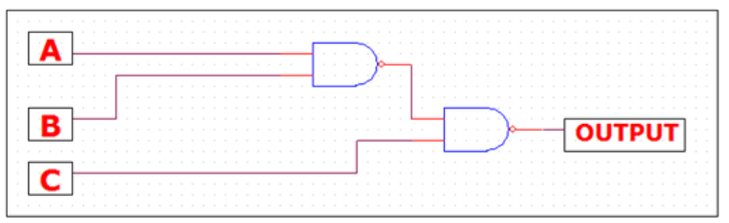
Figure 1 circuit diagram
According to the figure, A and B are connected to the input of the first NAND gate. Their output along with C are connected to another NAND gate which give the final output of the circuit.
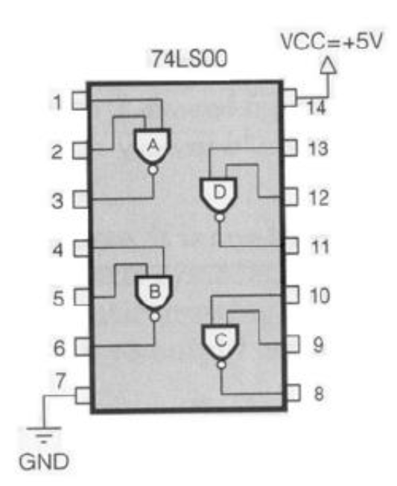
Figure 2 IC 74LS00 NAND chip
- The IC 74LS00 (NAND chip) is placed on the breadboard. (figure 3)
- 1 and 2 are the inputs of the NAND gate A.
- Output of A and C are connected to the 9 and 10 inputs of the NAND gate C.
- The output of C is the final output of the digital circuit.

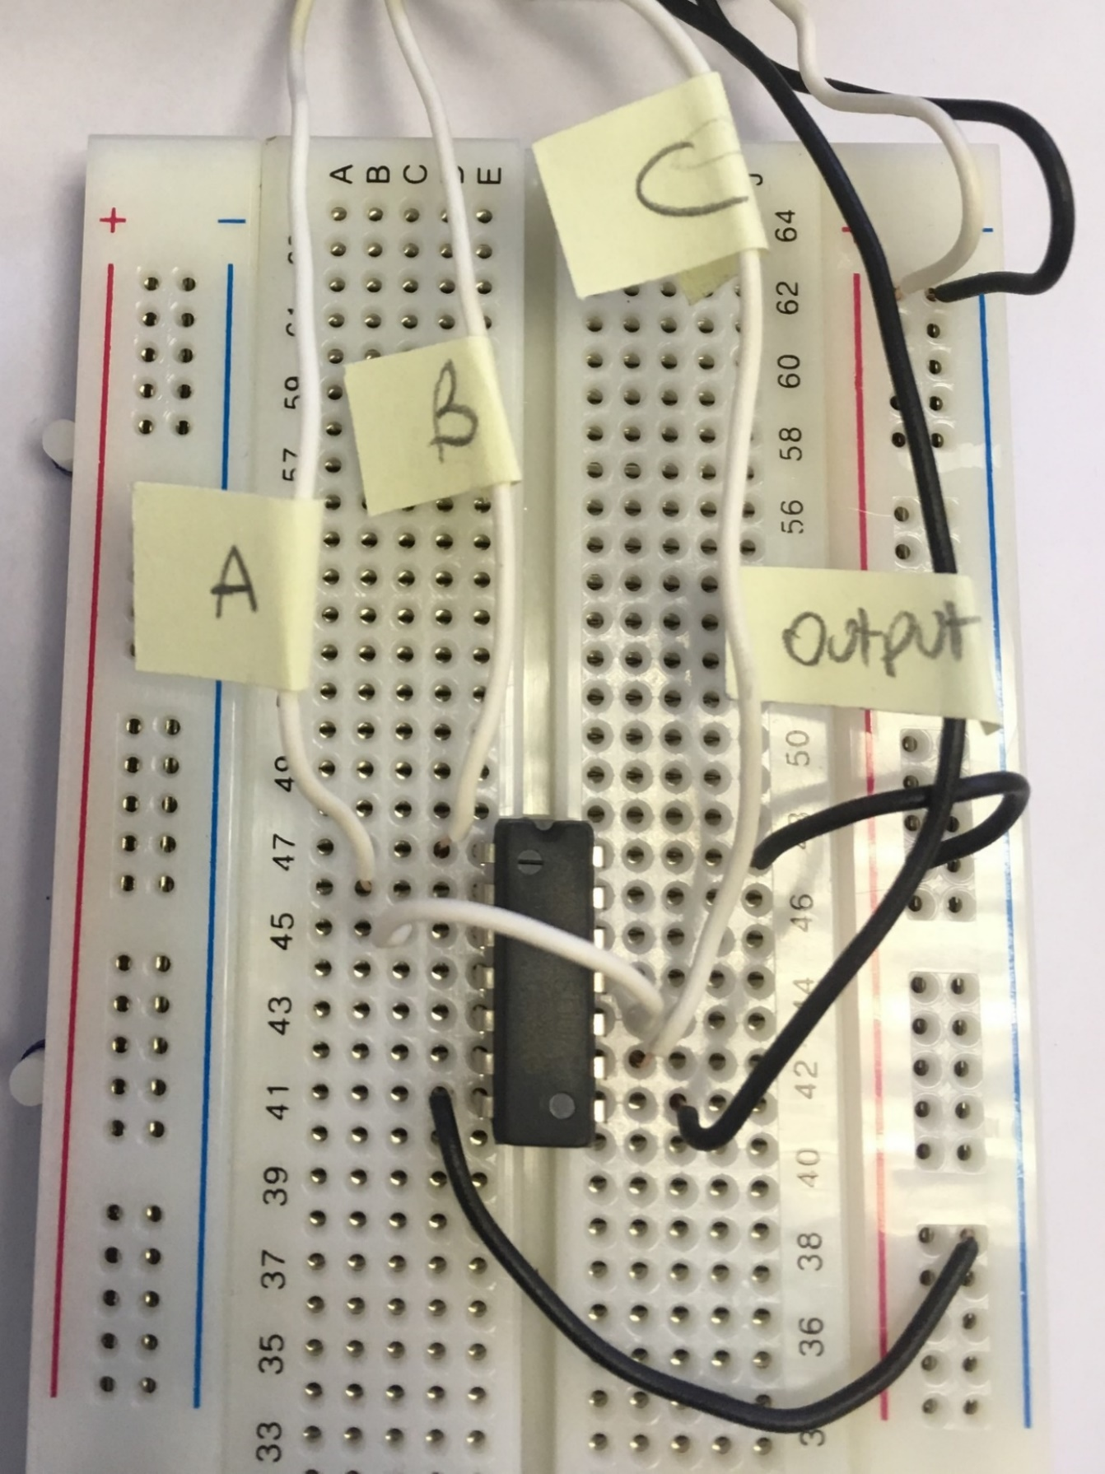
Figure 3 Circuit Connections

Connections between MyDAQ acquisition board and the circuit:

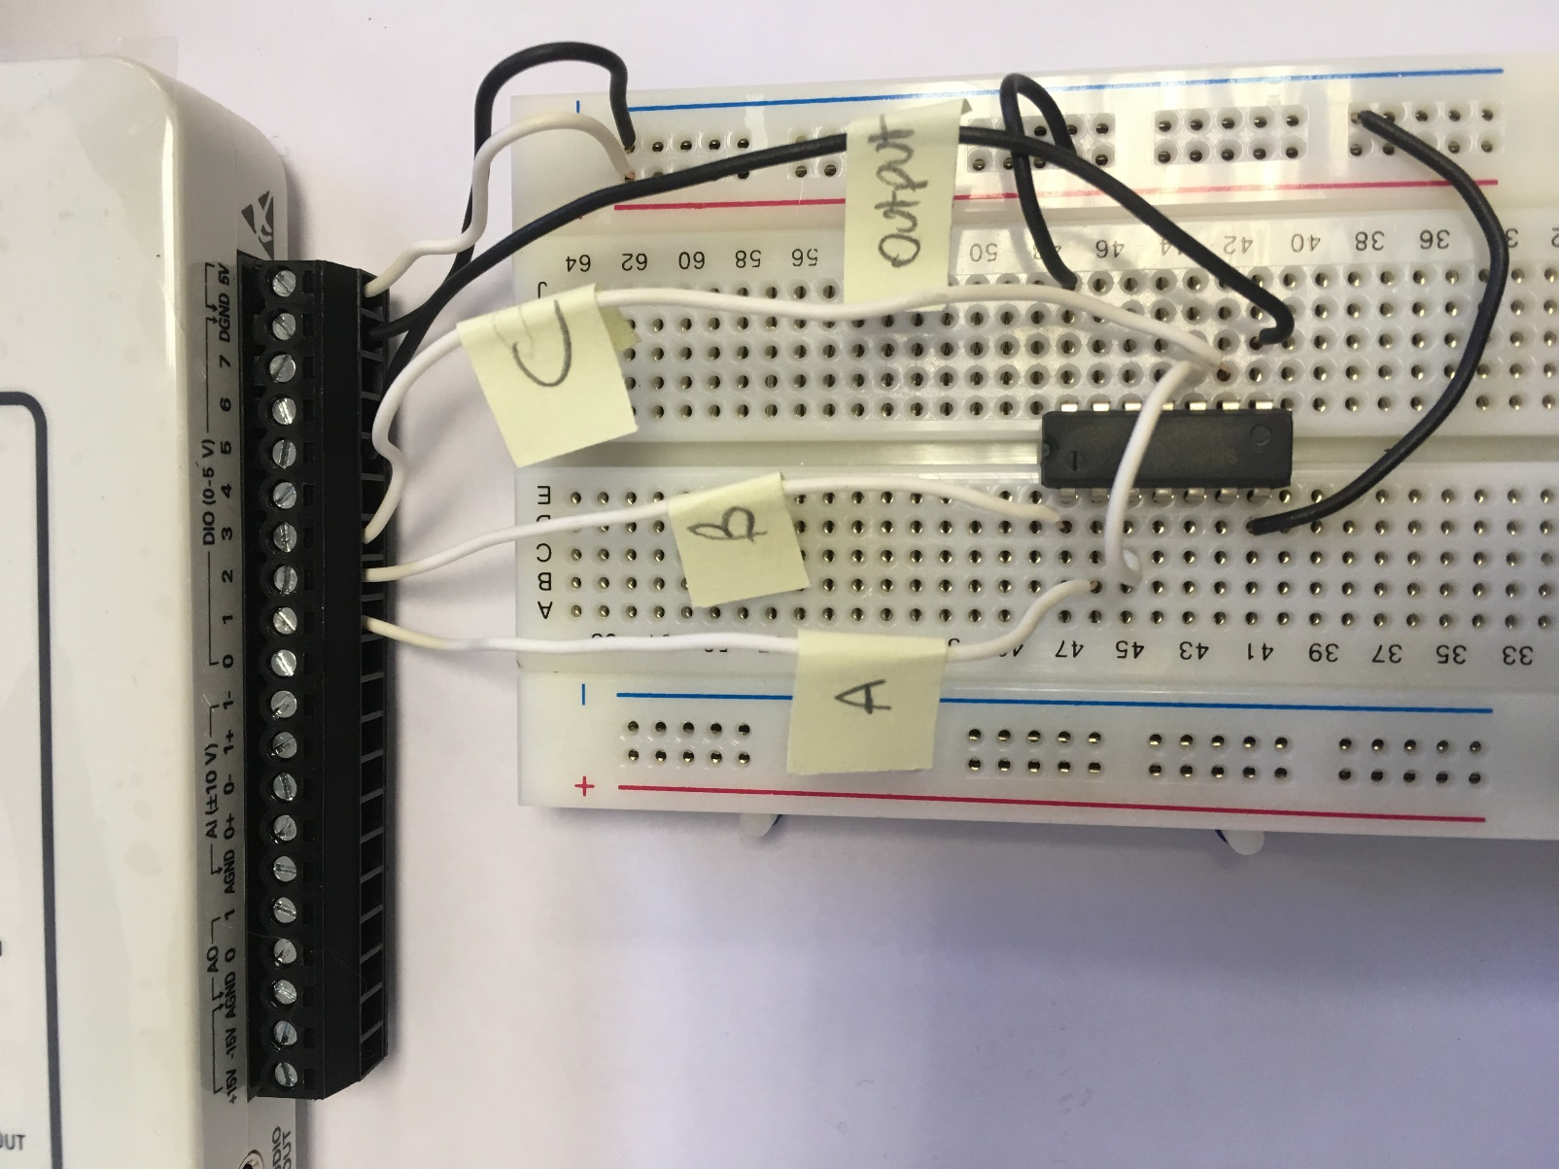
Figure 4 Connections between MyDAQ acquisition board and the circuit

Input and output lines:

- Connect pin 7 of the chip to the ground in the MyDAQ.
- Connect pin 14 of the chip to the VCC 5 V of the MyDAQ.
Lines 1,2, and 3 are used as digital outputs in the MyDAQ while line 5 is used as digital input.
- Connect digital output 1 of the MyDAQ to pin 2 of the chip.
- Connect digital output 2 of the MyDAQ to pin 1 of the chip.
- Connect digital output 3 of the MyDAQ to pin 9 of the chip.
- Connect digital input 5 of the MyDAQ to pin 8 of the chip.

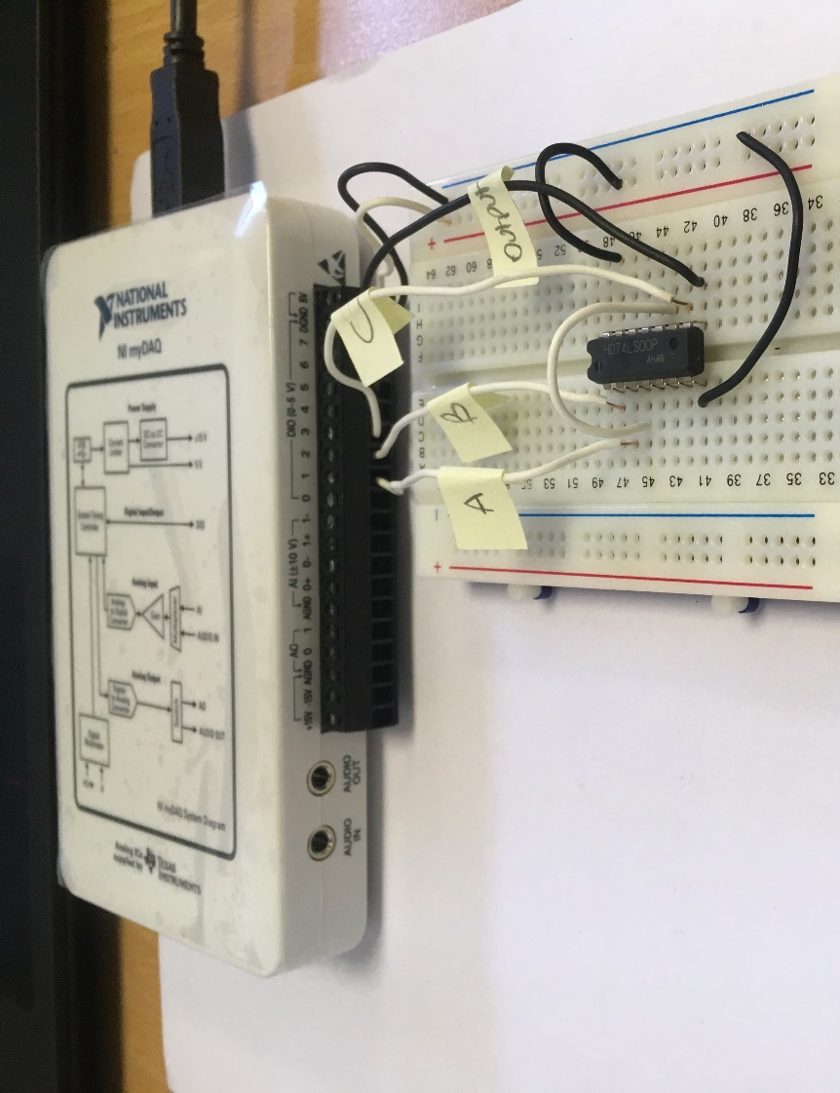
Photo depicting hardware setup and connections:
Figure 5 Hardware setup and connections

DESCRIPTION OF THE SOFTWARE SETUP

Modules used and configurations:
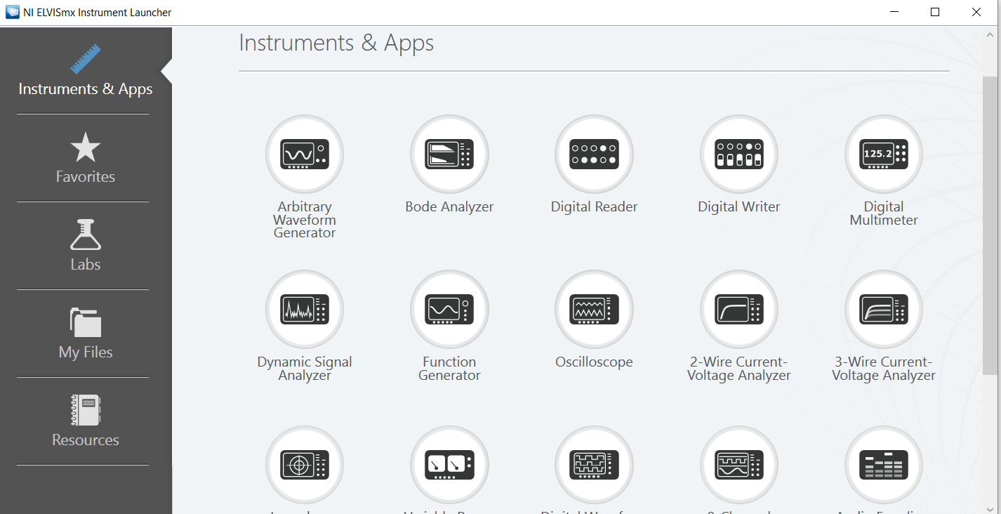
- Connect the MyDAQ to the PC, NI ELVISmx Instrument Launcher will start automatically:
Figure 6 NI ELVISmx Instrument Launcher
- Using the digital writer (figure 7), choose the lines (0-3) as digital outputs. Digital output lines of MyDAQ will be used as inputs to the circuit built on the breadboard
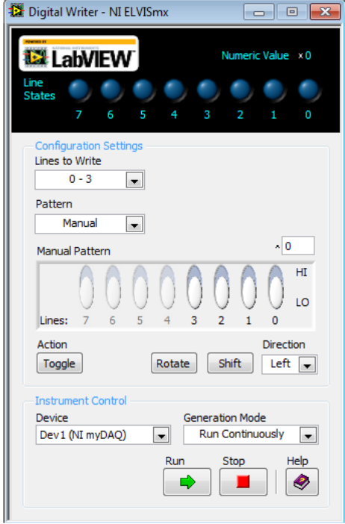
Figure 7 Digital Writer
- Using digital reader (figure 8), set the lines (4-7) as digital inputs. Digital input lines of MyDAQ will be used as outputs to the circuit built on the breadboard.
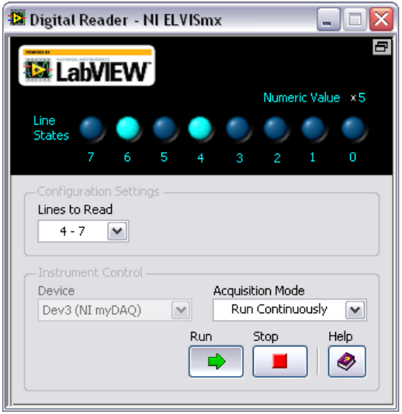
Figure 8 Digital Reader

TESTING

Select two different testing vectors.
A is chosen to be zero, so the two variable vectors are B and C.

Theoretical outputs of the chosen Test Vectors:

A | B | C | (AB) | (AB)’ | C(AB)’ | OUTPUT
0 | 0 | 0 | 0 | 1 | 0 | 1
0 | 0 | 1 | 0 | 1 | 1 | 0
0 | 1 | 0 | 0 | 1 | 0 | 1
0 | 1 | 1 | 0 | 1 | 1 | 0
Figure 9 Truth Table

The two highlighted rows in the truth table are shown in the screenshots
- For the first shaded row:
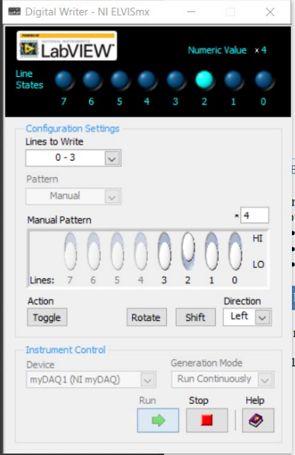
Output, line 5 in this experiment, is one.
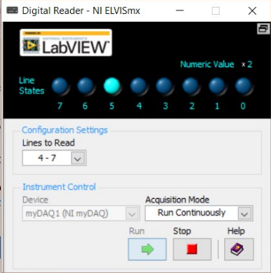
Figure 10 Digital Writer
Figure 11 Digital Reader
- For the second shaded row:
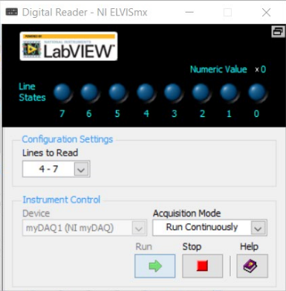
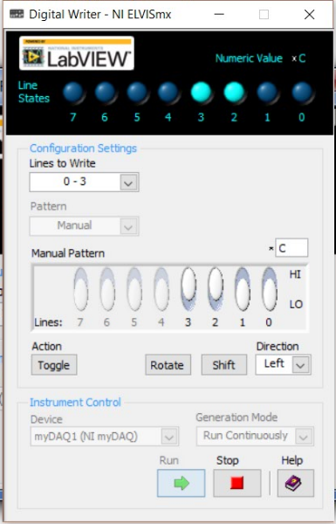
Output, line 5 in this experiment, is zero.
Figure 12 Digital Reader
Figure 13 Digital Writer

Output in this experiment is [C (AB)’]’

